Design Patterns Portfolio

**Michal Kubiak | T00205890**

7 Nov. 2021

Code Count: 1615

Word Count: 2994

**Strategy** is a behavioural design pattern that lets you define a family of algorithms, places each into a separate class, and interchange their objects. Strategy is used to isolate the business logic of a class from the implementation details. It is used when a class has a lot of conditions or operations.

**The Pros** of Strategy implementation details are isolated from the code that uses them, inheritance can be replaced with composition, and the **Open Close Principle** can introduce new strategies without changing the context. **The Cons** are that your clients need to be aware of the differences between strategies to select a proper one. If you have a couple of algorithms that rarely change, then there is no reason to overcomplicate the code with new class interfaces that come along with the Strategy Pattern.

Let’s say in our application, we want a user to store files or upload pictures. The first thing we would usually do is compress that file. There are different types of image compression algorithms, such a JPEG, for example. Then, we can apply a filter, for example, a black and white filter.

We need a few private fields which determine the compression type and the filter we will use. The first field will be a String called compression, it would be better to use an Enum, but for simplicity, I went with String to demonstrate this problem and the Design Pattern. Another field was created called filter also of type String.

These fields can be initialized using a constructor, after which we can check the compression and filter types in the storeFile method. Next, we can apply a filter and system out print a corresponding message. Instead of the messages, in an actual application, we would use algorithms. This hypothetical class demonstrates the initial problem and applies a **Strategy Design Pattern** to ensure more flexible.

package com.michalkubiak.strategy;  
  
public class FileReader {  
  
 *// Changed the type to Compression instead of String | Also Filtering* private String compression;  
 private String filter;  
  
 *// Change the FileReader compression type from String to Compression* public FileReader(String compression, String filter) {  
 this.compression = compression;  
 this.filter = filter;  
 }  
  
 *// We now simply get rid of the if else statements and delegate this request to store the file  
 // To a separate object, and pass the file name to the compression method of the  
 // Compression object, The could be named differently but for simplicity I went  
 // With just the same names, in a real production environment they would have better  
 // Naming Conventions!* public void storeFile(String file){  
 if(compression.equals("jpeg"))  
 System.*out*.println("Compressing using jpeg"); *// this would be an actual algorithm* else if (compression.equals("png"))  
 System.*out*.println("Compressing using png");  
   
 if (filter.equals("BlackAndWhite"))  
 System.*out*.println("Applying"); *// and so on* }  
}

There are several problems with this code or this example of a class in an application. This class is violating the **Single Responsibility Principle** because this implementation is responsible for storing the file. It is also responsible for checking the compression type and checking the filter or applying one. As this class gets bigger, it becomes unmaintainable. Which means we are violating the SRP principle. The second issue is that it would be hard to support new compression types or filters as we would have to add more if statements.

We want our file reader to behave differently depending on the compression or filter type we use. We can introduce a Compression interface with a method compression. Then we create concrete classes that implement these interfaces. With this structure, we are following the **Open Close Principle.** If we want to add a new compression type, we just make a new class that implements the Compression interface. In our FileReader class, we would change the compression type to Compressor to maintain a reference to the compressor object.

This is what we call the Strategy Pattern. The Gang of Four book has a structure of the Strategy Pattern while is the same as the one above. Only the FileReader is ‘Context’, the Interface is the ‘Strategy’, and the JPEGCompression would be a ‘ConcreteStrategy’. It is similar to the State Pattern, both are structurally similar, and both are used to change the behaviour of an object.

The difference between the State and Strategy Pattern is that the FileReader object can have a single state in the State Pattern. All the behaviours are represented by a subclass of the interface or abstract class it references. In the Strategy Pattern, we do not have a single state. Different behaviours are defined using different strategy objects. State would be considered an extension of Strategy, where both are based on composition but Strategy makes the helper objects independent. State does not restrict dependencies.

Compression Interface

package com.michalkubiak.strategy;  
  
public interface Compression {  
  
 *// This would usually be the case as the files would be compressed in bytes  
 // byte[] compression(byte[] file);  
  
 // For simplicity, we will just have a string here to demonstrate Strategy.* void compression(String file);  
}

Concrete Class

package com.michalkubiak.strategy;  
  
*// This concrete class implements the compression interface  
// Another class called PNGCompression could be created, as any other  
// Class using different compression types.*public class JPEGCompression implements Compression{  
 @Override  
 public void compression(String file) {  
 System.*out*.println("Compression done with JPEG Algorithm");  
  
 }  
}

Filtering Interface and subsequent filter class implementation

package com.michalkubiak.strategy;  
  
public interface Filtering {  
 void filter(String file);  
}

package com.michalkubiak.strategy;  
  
*// Concrete implementation*public class BlackAndWhite implements Filtering {  
 @Override  
 public void filter(String file) {  
 System.*out*.println("Apply Black And White Filter to image file");  
 }  
}

File Reader Type Changes for Compression Type and Filter Type:

package com.michalkubiak.strategy;  
  
public class FileReader {  
  
 *// Changed the type to Compression instead of String | Also Filtering* private Compression compression;  
 private Filtering filter;  
  
 *// Change the FileReader compression type from String to Compression* public FileReader(Compression compression, Filtering filter) {  
 this.compression = compression;  
 this.filter = filter;  
 }  
  
 *// We now simply get rid of the if else statements and delegate this request to store file  
 // To a separate object, and pass the file name to the compression method of the  
 // Compression object, The could be named differently but for simplicity I went  
 // With just the same names, in a real production environment they would have better  
 // Naming Conventions!* public void storeFile(String file){  
 compression.compression(file);  
 *// Filter method of Filter concrete class  
 // Now we have flexibility in our Main class when using the File Reader!* filter.filter(file);  
  
 }  
}

Main Class Showcase and Use Cases:

package com.michalkubiak;  
  
import …  
  
public class Main {  
  
 public static void main(String[] args) {  
  
 *// We create a new fileReader which does JPEG compression on a file  
 // In this case an image let’s say  
 // And will apply JPEG Compression and a Black and White filter!* var fileReader = new FileReader(  
 new JPEGCompression(),  
 new BlackAndWhite()  
 );  
  
 *// Apply the store file method* fileReader.storeFile("Family Photo");  
 };  
}

When the app is compiled, we can see that the string ‘’Family Photo” has had a JPEG compression applied and was filtered Black And White.

The application can now be extended by creating more filters or compression methods classes that implement their interfaces, making the app more maintainable and more flexible in the future!



Figure . Strategy Design Pattern UML Class Diagram

Strategy favours composition over inheritance. It ensure more flexibility, encapsulating a family of algorithms into their own set of classes, the behaviour can also be changed at runtime.

**Template Method** is a behavioural design pattern that defines the skeleton of an algorithm in the superclass but lets subclasses override specific steps of the algorithm without changing its structure.

Let’s say we are making a Banking Application, and we are to record the user’s activities in a trail and record who did what and when. Because we have different *types* of tasks, we do not want to implement these methods of a single class because every time we want to change the Task, we would have to come back and modify this Banking App Class.

We want our system to be **Closed for Modification & Open for Extensions**. Each Task should be a separate class. We created a class called RecordActivities which would, in a real application, record a user’s Task of transferring funds. Now we add a second and third class which saves a report and transfers funds. There is a couple of problems with the implementation of these classes in the figure below.

package com.michalkubiak.template;  
  
public class TransferFunds{  
  
 private RecordActivities recordActivities;  
  
 public TransferFunds(RecordActivities recordActivities1) {  
 this.recordActivities = recordActivities1;  
 }  
  
 public void Task(){  
 *// this records the activities* recordActivities.record();  
 System.*out*.println("Funds Transferred");  
 }  
}

package com.michalkubiak.template;  
  
public class SaveReport {  
  
 private RecordActivities recordActivities;  
  
 public SaveReport(RecordActivities recordActivities) {  
 this.recordActivities = recordActivities;  
 }  
  
 public void task(){  
 recordActivities.record();  
  
 System.*out*.println("Save Report");  
 }  
}

package com.michalkubiak.template;  
  
public class RecordActivities {  
  
 *// In a real application, this method would have parameters for capturing  
 // information about the user* public void record() {  
 System.*out*.println("Record Activities");  
 }  
}

The first problem is the **duplication of code.** Every new Task needs to record the activities after adding the RecordActivities class’ method record() and initializing it with a constructor. It is too repetitive. There is also no structure to follow. A new task does *not* have to reference the record() function. There is no safety net for a new task to have this method in any new task.

The Template Pattern uses inheritance to solve this problem. TransferFunds and SaveReport would typically call the recordActivities.record() method, code duplication. We can have them extend a common class called Task, where we move that common behaviour. The concrete classes will **extend** the Task abstract class, call the callExecute() abstract method, and override it. When the class is extended, the behaviour will be determined. We introduce a callExecute abstract method and call it in the execute method. Task, being an abstract class, can only be extended.

**The pros** of this pattern are that it lets clients override various sides or parts of a more extensive codebase or algorithm, so they are less affected by changes to other features. Duplicated code is decreased by putting it into the superclass. **The cons** are that the client will be limited to only the provided template. The **Liskov Substitution Principle** could be violated by not having a default implementation step in the subclass. Generally, the Template method is more brutal to maintain the bigger the algorithms or steps along the way get.

Because our execute method defines a template or skeleton for an operation, the Gang of Four book, the Template method is demonstrated by extending a concrete class to an abstract class with a ‘templateMethod’ and some primitive abstract operations. A concrete class will extend the abstract class overriding or implementing those primitive operations, also known as hooks. A note here is that the primitive methods (or, in this example, the callExecute() method) do not have to be abstract, it is up to the subclass to decide whether or not it needs overriding.

Creating the Task class, making it abstract, and adding the execute method, calls the callExecute abstract method and the record() method from the RecordActivities class.

package com.michalkubiak.template;  
  
public abstract class Task {  
 private RecordActivities recordActivities;  
  
 *// Default constructor implementation* public Task(){  
 recordActivities = new RecordActivities();  
 }  
  
 public Task(RecordActivities recordActivities) {  
 this.recordActivities = recordActivities;  
 }  
  
 *// Template for executing our tasks* public void execute() {  
 recordActivities.record();  
  
 *// what happens after here is determined by the subclasses* callExecute();  
 }  
  
 protected abstract void callExecute();  
}

TransferFunds extends Task, implementation of the callExecute method. Further duplicate code decrease.

package com.michalkubiak.template;  
  
public class TransferFunds extends Task{  
  
 @Override  
 protected void callExecute() {  
 *// Here we define our logic for executing the transfer of funds* System.*out*.println("Funds Transferred");  
 }  
}

In the main class, a new Task object has access to both execute and callExecute methods. We can change this by making the abstract methods **protected.** Otherwise, the callExecute method, if called, will not record the activities in the execute() method, which goes against the purpose of the template method.

In addition, the Template Method also follows the **Hollywood Principle,** which states, don’t call us, we’ll call you. The subclasses are used to provide implementation details. The abstract callExecute method is never directly called by the subclasses.

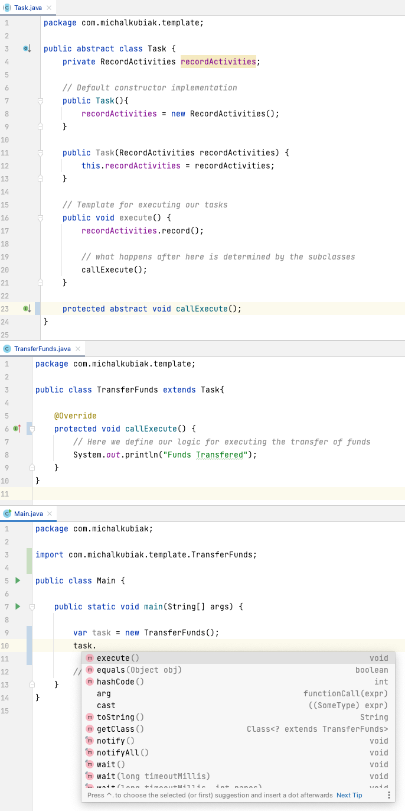

Figure . Protected callExecute cannot be accessed in the main driver

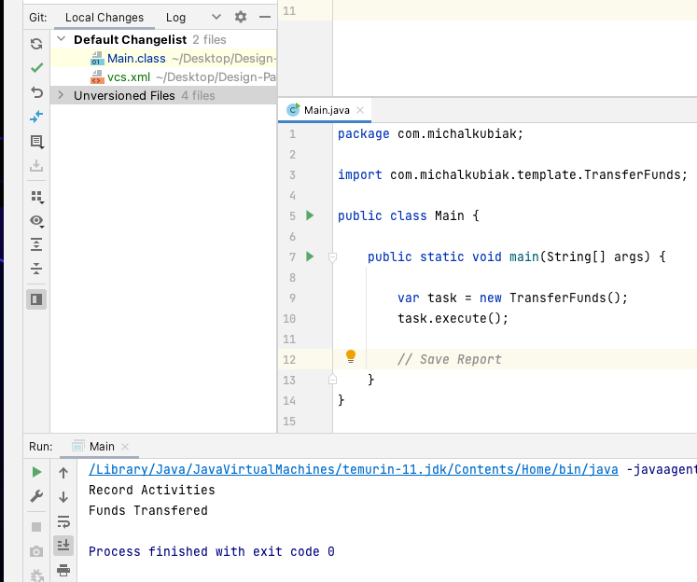

Figure . Transfer Funds new instance which now records the activities and executes the transfer of funds - Save Report can optionally be also implemented

**Command** is a behavioural design pattern that turns a request into a stand-alone object containing all the requested information. This transformation lets you pass requests as a method arguments, delay or queue a request’s execution, and support undoable operations.

Great Software Design should be based on **Separation of Concern**. An example would be a GUI layer with the interface logic and another layer for business logic. A button looks pretty but delegates the operation to the underlying business logic layer.

For this example, we are making a mini-framework that other developers can use. In this framework, we will have a button, a checkbox and a textbox. The first implementation of the problem begins with making a button class. For example, this button class has a click method, but this click's logic can vary depending on the button. The command pattern aims to solve this problem.

When building our framework and the button class, we need to call an execute() method of the Command object to delegate or forward the execution of the button logic. When someone wants to use our framework and our button to build a GUI, they will implement the Command interface inside of a class called AddUser. Inside the execute() method of *that* class, he will call the addUser() method of the UserService class. The concrete implementation of AddUser is delegating work to the UserService class, so the business logic is separated.

The Invoker class talks to the Command interface. We have concrete implementations of this interface that delegate work to a receiver, such as a UserService class in our example. The point is to decouple the invoker from the receiver. With this structure, the Invoker can talk to the receiver without being *aware* of it, which is the intent of the Command Pattern to decouple the sender from the receiver.

Because we are representing each request using a Command object, there are several things we can do with them, such as pass them around in our code, we can pass them as arguments to our methods, we can also add them to a list. We can, for example, track all the commands that have been executed and replay them or undo them. We can also store them in a database and execute them in the future.

We initialize a command interface and execute the execute() method in the click() method of the button without knowing what it would do in the future. Any button logic can now be applied when a concrete implementation of this interface is made.

A unique real life example of a command would be a progress bar where a series of installation objectives are a list of commands with an estimate time for each one. A composite list of commands would add the time together to structure a progress bar.

package com.michalkubiak.command;  
  
public interface Command {  
 void execute();  
}

package com.michalkubiak.command;  
  
public class Button {  
  
 private String label;  
 *// Adding a new Command field* private Command command;  
  
 *// Adding a Constructor to initialize the command field* public Button(Command command) {  
 this.command = command;  
 }  
  
 public void click(){  
 command.execute();  
 }  
  
 public String getLabel() {  
 return label;  
 }  
  
 public void setLabel(String label) {  
 this.label = label;  
 }  
}

package com.michalkubiak.command;  
  
public class UserService {  
  
 public void addUser() {  
 System.*out*.println("Add User");  
 }  
}

package com.michalkubiak.command;  
  
public class AddUserCommand implements Command{  
 private UserService userService;  
  
 public AddUserCommand(UserService userService) {  
 this.userService = userService;  
 }  
 @Override  
 public void execute() {  
 userService.addUser();  
 }  
}

The UserService in some hypothetical application now has the business logic for adding a user. We created a command object, AddUserCommand, which implements the command interface to use our button framework. Here, we have the execute() method, which delegates the work to the UserService by calling the UserService,addUser() method.

Now in the main class w create a new UserService object and pass it into a new AddUserCommand object as a command variable. Next, we need to add a button from our framework, not java.awt, just an observation. Passed in the command object into the button, and we call the click method. All of the objects are now collaborating correctly, and the button now adds a user.

package com.michalkubiak;  
  
import com.michalkubiak.command.*;  
  
public class Main {  
  
 public static void main(String[] args) {  
  
 var service = new UserService();  
 *// we need to pass this service into the AddUserCommand* var command = new AddUserCommand(service);  
 *// Pass this object into the button* var button = new Button(command);  
 *// perform click, which goes back to the user service and adds the user.* button.click();  
  
 }  
}

Output:

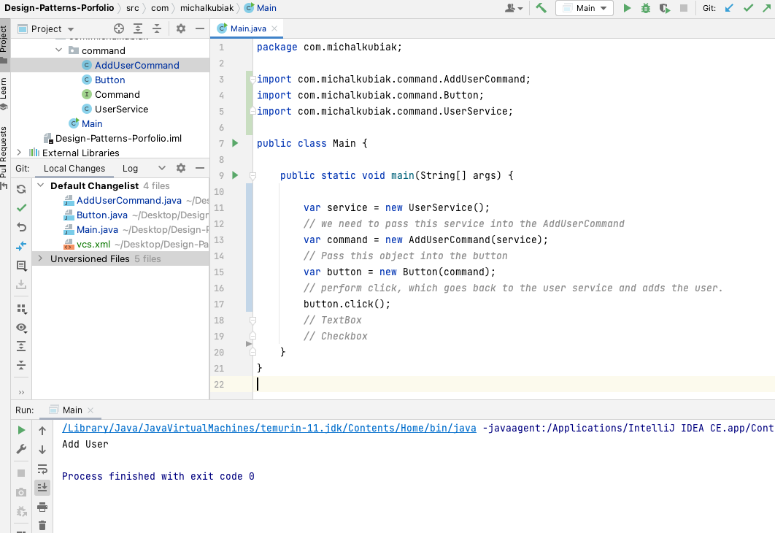

**Composite Commands:**

Some programs like photoshop allow you to record actions and reply to them later. The Command Pattern lets you implement such features. We create a CropImage command class and a Filter command class. Now to record user actions, we will create a new Command class which will be a container for other commands, which will execute all of the commands. This is done by making a **List** of commands, a method that adds a command to the list, and a for loop in the execute() method to execute each command.

package com.michalkubiak.command;  
  
import java.util.ArrayList;  
import java.util.List;  
  
public class CompositeCommand implements Command {  
 private List<Command> commands = new ArrayList<>();  
  
 *// A method which adds commands to the commands ArrayList* public void add(Command command){  
 commands.add(command);  
 }  
 @Override  
 public void execute() {  
 for (var command: commands){  
 command.execute();  
 }  
 }  
}

package com.michalkubiak;  
  
import com.michalkubiak.command.*;  
  
public class Main {  
  
 public static void main(String[] args) {  
  
 var service = new UserService();  
 *// we need to pass this service into the AddUserCommand* var command = new AddUserCommand(service);  
 *// Pass this object into the button* var button = new Button(command);  
 *// perform click, which goes back to the user service and adds the user.* button.click();  
  
 var composite = new CompositeCommand();  
 *// Let’s say a user wants to crop and image and filter it with one button  
 // We add those commands into this composite command* composite.add(new CropImageCommand());  
 composite.add(new FilterCommand());  
  
 *// We can now execute every command in the composite object* composite.execute();  
  
 }  
}



Figure . Command Pattern UML Class Diagram with Composite Commands

**Undo Commands:**

Another benefit of the Command Pattern is that it lets you undo mechanisms. This is done by introducing another interface called UndoCommand, which has an unexecute() method. The UndoCommand interface would extent the Command Interface. It will inherit the execute method but will also introduce the unexecute() method.

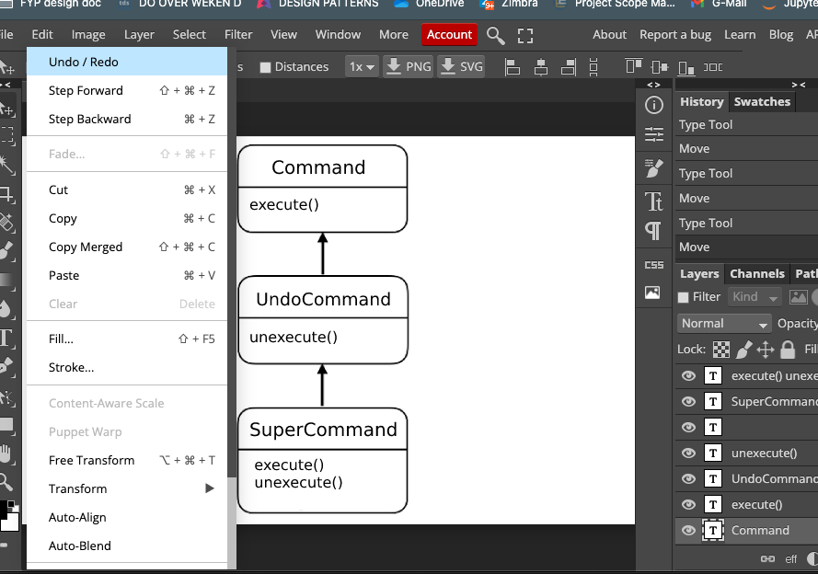

Figure . Example of an Undo Command in Photoshop

The UndoCommand interface will be now implemented into a SuperCommand class. We can use the memento pattern to implement undo mechanisms. We store the changes in the state of an object so that we can store multiple snapshots over time. For example, more significant file operations such as videos would be expensive in terms of memory to operate on. Command Pattern makes it more accessible as every command knows how to undo itself, like resizing a video where you would for example store the previous dimension of the video to undo the change.

The SuperCommand would have a field of String which would have the videos previous dimensions for example.

The Command Pattern implements the **Open Close Principle**, new commands can be introduced without breaking the existing code. It also implements the **Single Responsibility Principle** and decouples classes which have operations from those that perform them. The code can however become very complicated as there is a new layer between sender and receiver classes.

The SuperCommand can be used in application in the following way. It has a field called prevDimension of a video let’s say. This SuperCommand object needs to talk to a Document object, which would have a method called executeSuper(), it gets the execute and unexecute methods forwarded to it.

The SuperCommand also needs to talk to a History object. The history method has a push and pop method. The execute() method of the SuperCommand recalls document to get the dimensions, then store it into the prevDimension field. The we executeSuper() from the document object, then push it into the history object. The unexecute() method is simple, it sets the dimensions of the document to the prevDimension value. And of course we introduce the UndoCommand class. History.pop() will retrieve the last command that was applied, and unexecute the command itself.

The page class knows nothing about the command objects, it is strictly for business logic. The History object keeps track of the commands we executed. The concrete implementation of the command interface which delegates work to the Page object which has the business logic. The ItalicCommand object takes in a page and a history object. The ItalicCommand.execute() will put <i> wrappers around the body of the page after it is set. The UndoCommand class will unexecute the last command in the history object. History.pop will give us the last command. The History class has a size method which is checked in the UndoCommand method. All these objects perform complex tasks such as undoing a command by collaborating.

package com.michalkubiak.pageEditor;  
  
public interface Command {  
 void execute();  
}

package com.michalkubiak.pageEditor;  
  
import java.util.ArrayDeque;  
import java.util.Deque;  
  
public class History {  
  
 *// Short for double que - it allows adding of objects  
 // from both front and the end of the list* private Deque<UndoableCommand> commands = new ArrayDeque<>();  
  
 *// Takes an undoable command and adds it to the list* public void push(UndoableCommand command) {  
 commands.add(command);  
 }  
  
 public UndoableCommand pop() {  
 *// Return the current pop* return commands.pop();  
 }  
  
 public int size() {  
 return commands.size();  
 }  
}

package com.michalkubiak.pageEditor;  
  
public class UndoCommand implements Command {  
 private History history;  
  
 public UndoCommand(History history) {  
 this.history = history;  
 }  
  
 @Override  
 public void execute() {  
 if (history.size() > 0)  
 history.pop().unexecute();  
 }  
}

package com.michalkubiak.pageEditor;  
  
public interface UndoableCommand extends Command {  
 void unexecute();  
}

package com.michalkubiak.pageEditor;  
  
public class Page {  
 private String body;  
  
 *// Business Logic - Making some page content italic* public void makeItalic() {  
 body = "<i>" + body + "</i>";  
 }  
  
 public String getBody() {  
 return body;  
 }  
  
 public void setBody(String body) {  
 this.body = body;  
 }  
}

package com.michalkubiak.pageEditor;  
  
*// This is a command which can be undoable so it implements UndoableCommand*public class ItalicCommand implements UndoableCommand {  
  
 private String previousBody;  
 private Page page;  
 private History history;  
  
 public ItalicCommand(Page page, History history) {  
 this.page = page;  
 this.history = history;  
 }  
  
 @Override  
 public void execute() {  
 previousBody = page.getBody();  
 page.makeItalic();  
 history.push(this);  
 }  
 @Override  
 public void unexecute() {  
 page.setBody(previousBody);  
 }  
}

package com.michalkubiak;  
  
public class Main {  
  
 public static void main(String[] args) {  
  
 var history = new History();  
 var page = new Page();  
  
 page.setBody("New Body");  
  
 *// Command object which would be  
 // linked to a button perhaps* var italicCommand = new ItalicCommand(page, history);  
 italicCommand.execute();  
 *// Check the page body* System.*out*.println(page.getBody());  
  
 *// Checks history and undoes the <i> italic command* var undoCommand = new UndoCommand(history);  
 undoCommand.execute();  
 System.*out*.println(page.getBody());  
  
 }  
}



Figure . Undo Command Implementation with History

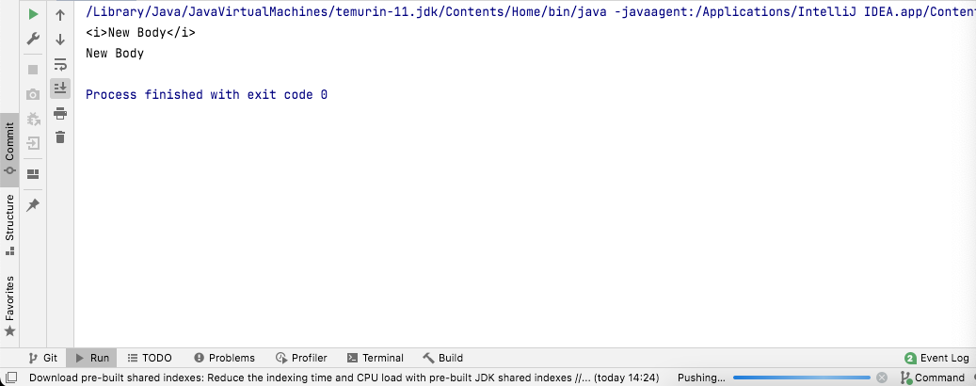

Figure . Undo Command Output

**Observer** is a behavioural design pattern that lets you define a subscription mechanism to notify multiple objects about any events that happen to the object they’re observing.

It is about **push vs pull.** Pulling for changes becomes absurd when there is a number of objects which want to know the state of another object at any given time. Observer helps us with pushing when the state has changed.

Source will talk to the Calendar and Chart objects through a common observer interface. This structure follows the **Open Close** principle. With adding and removing observer methods we can dynamically adjust the observer objects. The interface will have an update method, and the Source will have a getter and setter for the Number value. We also have polymorphic behaviour with the notify method inside the Source class. Observer also follows **ISP** because the Subject and Observer are small with their own jobs for the observer to do.

In this example we have a Source of data which extends the Observable object which notifies anything that implements the Observer interface.



Figure . Observer Pattern UML Class Diagram

Because the Subject or Observable pushes the changes to the observers, the concrete observer is not dependant on the concrete subject as it gets the data with the update method.

With the pull style, the concrete observer and subject are coupled. They can however pull the data from the subject with getNumber(), there is more flexibility here apart from the coupling. New observers can be added with new data so this makes it so we do not have to change the subject class the whole time. **The pros** are the Open Close principle is followed and the cons are that subscribers are notified of the changes in a random order, this might be a problem for very large and complex systems, or precise applications.

**Push Style** is not very flexible as we are using a primitive integer number in the notify methods, but here is an example of the code and the output.

package com.michalkubiak.observer;  
public interface Observer {  
 void update(int number);  
}

package com.michalkubiak.observer;  
  
*// Subject*public class Observable {  
 private List<Observer> observers = new ArrayList<>();  
 public void addObserver(Observer observer) {  
 observers.add(observer);  
 }  
 public void removeObserver(Observer observer) {  
 observers.remove(observer);  
 }  
 public void notifyObservers(int number){  
 for(var observer : observers){  
 observer.update(number);  
 }  
 }  
}

package com.michalkubiak.observer;  
public class Source extends Observable{  
 private int number;  
  
 public int getNumber() {  
 return number;  
 }  
  
 public void setNumber(int number) {  
 this.number = number;  
 notifyObservers(number);  
 }  
}

package com.michalkubiak.observer;  
public class Calendar implements Observer{  
  
 @Override  
 public void update(int number) {  
 System.*out*.println("Calendar updated: " + number);  
 }  
}

package com.michalkubiak.observer;  
  
public class Chart implements Observer {  
  
 @Override  
 public void update(int value) {  
 System.*out*.println("Chart updated: " + value);  
 }  
}

package com.michalkubiak;  
public class Main {  
  
 public static void main(String[] args) {var source = new Source();  
 var calendar = new Calendar();  
 var calendar2 = new Calendar();  
 var chart = new Chart();  
 source.addObserver(calendar);  
 source.addObserver(calendar2);  
 source.addObserver(chart);source.setNumber(1);

}}

**Pull Style** is different in where we have a private Source field in the observer objects with a constructor. Now we can call Source.getNumber() to retrieve it. Pulling is more flexible.

package com.michalkubiak.observer;  
public interface Observer {  
 void update();  
}

package com.michalkubiak.observer;public class Observable {  
 private List<Observer> observers = new ArrayList<>();  
 public void addObserver(Observer observer) {  
 observers.add(observer);  
 }  
 public void removeObserver(Observer observer) {  
 observers.remove(observer);  
 }  
 public void notifyObservers(){  
 for(var observer : observers){  
 observer.update();  
 }  
 }  
}

package com.michalkubiak.observer;  
public class Calendar implements Observer{  
  
 private Source source;  
  
 public Calendar(Source source) {  
 this.source = source;  
 }  
  
 @Override  
 public void update() {  
 System.*out*.println("Calendar updated: ");  
 }  
}

package com.michalkubiak.observer;  
public class Chart implements Observer {  
  
 private Source source;  
  
 public Chart(Source source) {  
 this.source = source;  
 }  
  
 @Override  
 public void update() {  
 System.*out*.println("Chart updated: " + source.getNumber());  
 }  
}

package com.michalkubiak.observer;  
public class Source extends Observable{  
 private int number;  
  
 public int getNumber() {  
 return number;  
 }  
  
 public void setNumber(int number) {  
 this.number = number;  
 notifyObservers();  
 }  
}

package com.michalkubiak;  
public class Main {  
  
 public static void main(String[] args) {  
 *// write your code here* var source = new Source();  
 var calendar = new Calendar(source);  
 var calendar2 = new Calendar(source);  
 var chart = new Chart(source);  
  
 source.addObserver(calendar);  
 source.addObserver(calendar2);  
 source.addObserver(chart);  
  
 *// Set the number which then notifies the calendar and chart* source.setNumber(1);  
 }  
}

This gives the same result as before. UML Diagram below.



Figure . Pull Style Observer Implementation